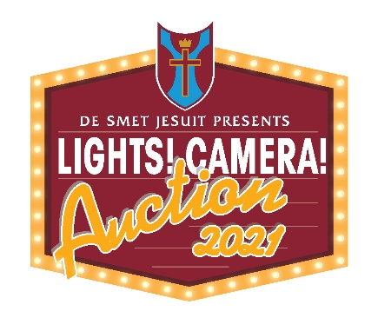
Program Ad Confirmation Form – Please Print
Business Name: _________________________________________________________ Date: ____/_____/_________
- Full Page | $650
- Half Page | $350
- Quarter Page | $200
Main Contact: ___________________________________________________________ Please select your ad size:
Phone: ____________________ Email:_______________________________________
Address:________________________________________________________________
City: ___________________________________ State: ________Zip _______________
Special Instructions: ________________________________________________________________________________________________
Website: ________________________________________________________ Amount Due: $____________
Payment Information: Check (Made payable to De Smet Jesuit High School) Credit Card
Credit Card Number: _____________________________________ Expiration Date: ____/____/____ 3-Digit CVV:_____
Name as is appears on the card:_______________________________________________________________________
Billing Address: ____________________________________________________________________________________
Ad Artwork Details
All artwork must be submitted in camera ready format as a high resolution PDF or .eps files. Your files should NOT include a bleed.
The deadline for receiving your artwork is January 21, 2019, to ensure inclusion in the program.

Ad sizes are as follows:
Full-Page/Cover | 7.50 w X 10 h
Half-page | 7.50 w X 5 h
Quarter Page | 3.75 w X 5.50 h

Thank you for your support!
Please return form to:
“Lights! Camera! Auction!” Gala & Auction
Attn: Becky Lane, Event Mgr., Institutional Advancement
233 N. New Ballas Rd.
St. Louis, MO 63141
Phone: 314-785-1276
Email: blane@desmet.org

